3D Printing Assignment Instructions
Overview
3D printing continues to increase in popularity and is being used in both K-12 and higher education settings (Ford & Minshall, 2019). 3D printing is being used in STEM, Makerspaces, project-based learning, and problem-based learning (Ford & Minshall, 2019). There are many advantages to using 3D printing in the classroom such as increased student engagement and student achievement (Ford & Minshall, 2019). However, there are also downsides to using 3D printing such as the amount of time to print an object, negative teacher attitudes, and teachers’ lack of knowledge of 3D printing (Ford & Minshall, 2019).
Instructions
For this assignment you will need to complete the following tasks:
- Create an object on Tinkercad which is a free 3D printer software; a link is located in the 3D Printing Resources. You will need to sign up for an account on Tinkercad if you do not have an account already. After you have created your object you will need to download your object as a .png file and upload the picture to Canvas. Here is how you download a picture from Tinkercad:

- After you have created your 3D object click “send to” 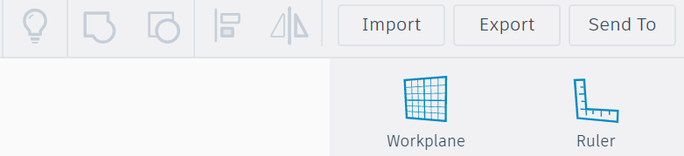
- A window will pop-up with a variety of options. Click on the arrow to download the object as a png file and submit the file to Canvas.
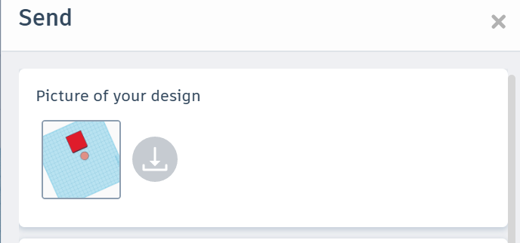

- Research locations in your community where you could print your 3D object. Please understand printing your object IS NOT required.
- You will research two 3D printers and compare their price, materials used to print, print resolution, print speed, and acceptable file format. You will use the 3D comparison chart within the 3D Printing Template. Then, choose which 3D printer you would recommend buying. You will want to provide at least 3 reasons why you believe the printer you chose is the better choice.
- Then write a 1–2-page proposal to an administrator recommending a specific (by name) 3D printer to purchase and explain how a 3D printer could be implemented into the curriculum. You will need to cite at least two current (within 5 years) scholarly, peer reviewed sources as you explain how a 3D printer could be implemented into the curriculum.
You must use the attached 3D Printing Template for this assignment.

